

School of Computer Science, UPES, Dehradun.

A

Lab 4

On Software Engineering

B.TECH. - V Semester

**Submitted to:**

Dr. Hitesh Kumar Sharma

**Submitted by:**

Name: Ishika Mehrotra

Batch: Devops B1

Sap Id: 500124411

Roll No.: R2142230281

**Lab Exercise 4- Signed Commits in Git and GitHub**

**Objective:**  
To configure Git to sign commits with GPG, push them to GitHub, and verify commit authenticity for secure code contribution.

**Step 1 – Generate or Use an Existing GPG Key**

1. **Check for existing keys**



1. **If no key exists, generate a new one**

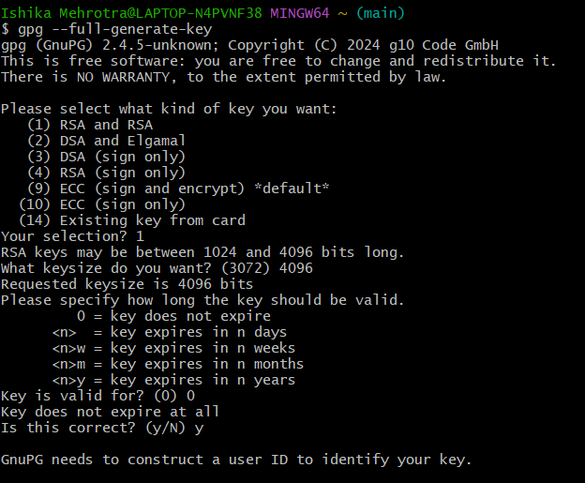

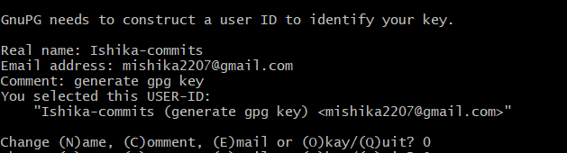

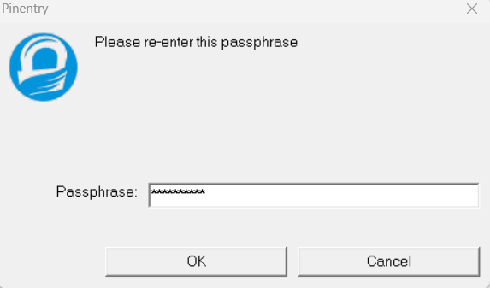

1. **Get your key ID**

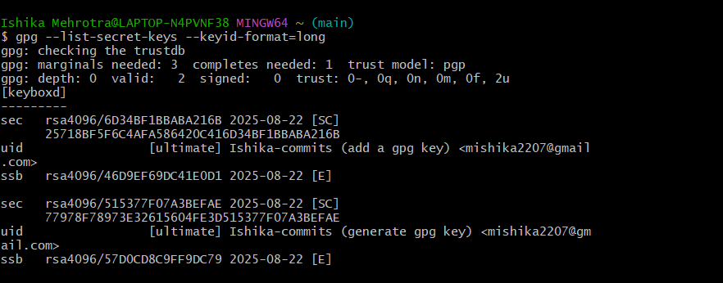

**Step 2 – Add GPG Key to GitHub**

1. Export your public key:

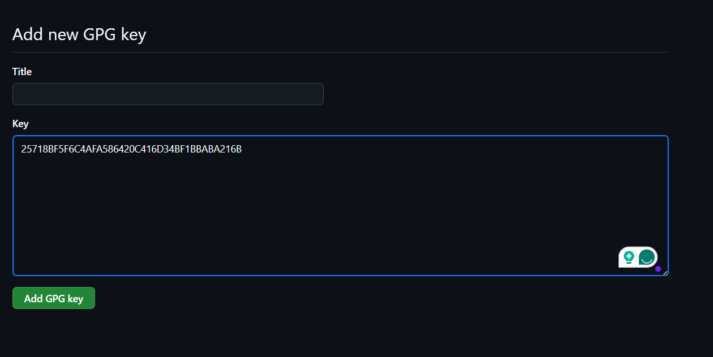

**Step 4 – Make a Signed Commit**

Clone your repo (or use an existing one):

